TO CREATE, EXPORT AND VALIDATE A DIGITAL CERTIFICATE.

AIM: To write a code to Create, Export and Validate a digital Certificate.

STEPS:
1.Download and Install opensol
2.Add its bin path in environmental variable
3.Open command prompt

PROGRAM:
C:\User\Ritesh\Desktop>openssl req -x509 -days 365 -newkey rsa:2048 -keyout private-key.pem -out certificate.pem Enter PEM Pass: 123456
Country Name (2 letter code) []: IN
State or Province Name (full name) []: Maharashtra
Locality Name []: Mumbai
Organization Name []: SIWS
Organizational Unit Name []: IT
Common Name []: TMD
Email Address []: patwaritesh@gmail.com
C:\User\Vaishnavi\Desktop> openssl pkcs12 -export -in certificate.pem -inkey private-key.pem -out TMD.pfx
Enter Export Password: 123456
Verifying - Enter Export Password: 123456
C:\User\Vaishnavi\Desktop> openssl pkcs12 -in TMD.pfx -clcerts -nokeys -out public-key.pem
Enter Import Password: 123456
Import the certificate

OUTPUT:

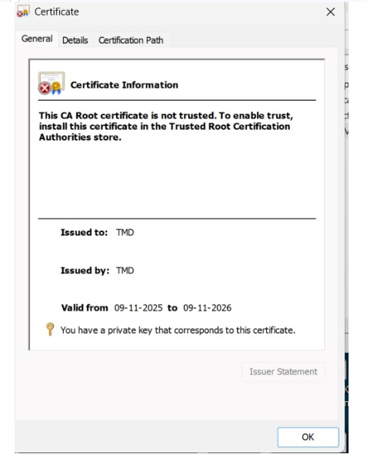

Conclusion:
The above creation is done successfully.

